**CURRICULAM VITAE**

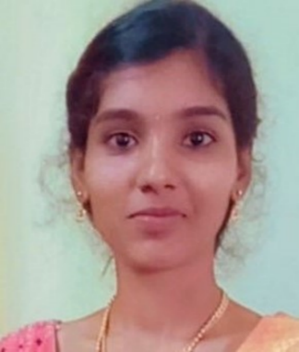NAME : B.Durga Veevais Deepa

D.O.B : 29/06/2004

AGE : 19

GENDER : Female

FATHER’S NAME : Mr.V.Balasubramanian

MOTHER’S NAME : Mrs.B.Usha

RELIGION : Hindu

MARITAL STATUS : Single

PLACE : Thanjavur

FATHER’S OCCUPATION : Crane Operator

MOTHER’S OCCUPATION : Home Maker

LANGUAGES KNOWN : Tamil, English, Hindi

**EDUCATIONAL QUALIFICATION:**

|  |  |  |
| --- | --- | --- |
| CLASS | BOARD | PERCENTAGE |
| 10th | St.Marcina’s Matric Hr Sec School,Ammapet. | 84% |
| 11th | St.Marcina’s Matric Hr Sec School,Ammapet. | 87% |
| 12th | St.Marcina’s Matric Hr Sec School,Ammapet. | 92% |

COMPUTER LITERACY:

* MS WORD
* MS OFFICE

TECHNICAL SKILLS:

* JAVA
* PYTHON
* DBS
* TYPING(English Senior)

HOBBY:

* LISTENING MUSIC
* READING BOOKS